

Document Version History

***Prepared by Webdunia***

***Version 1.0***

***Brothers Ecommerce***

***Framework Setup Document***

Webdunia (India) Pvt. Ltd.

Labh Ganga 582, M G Road

Indore 452 003

Madhya Pradesh, INDIA

Tel: +91-731-4273409  
Web: [www.webdunia.net](http://www.webdunia.net)

www.webdunia.com

|  |  |  |  |  |  |  |
| --- | --- | --- | --- | --- | --- | --- |
| **Version** | **Date** | **Addition/Modification** | | **Prepared By** | **Reviewed By** | **Approved By** |
| 1.0 | June 6, 2020 | Updated | Arth Kumar | | Gaurav V | Babita Jain |

Contents

1. Automation Framework SetUp 3

1.1 Java 3

1.1.1 Environment variables 4

1.2 Eclipse 4

1.2.1 Importing Project In-To the Eclipse 6

1.2.2 Importing from Local Repository: 8

# Automation Framework Setup

## Java

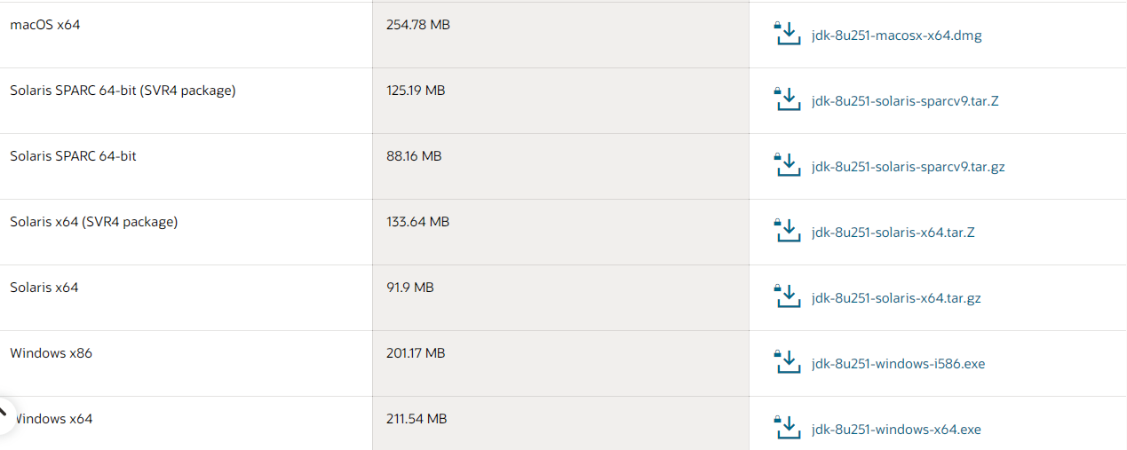

* Get the latest version of Java from the below URL:

<https://www.oracle.com/java/technologies/javase/javase-jdk8-downloads.html>

* Once downloaded, run it with the privilege guard.
* When Java window opens-up, click on Next button, and follow the prompt by clicking on Next button.

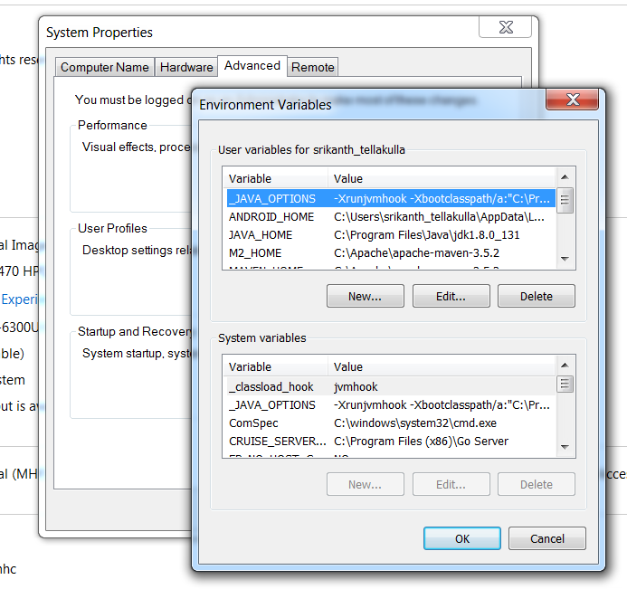

* After the installation is completed, we need to setup the environment variables.

**PATH: Control Panel -> System -> Advanced System Settings -> Advanced ->**

### Environment variables

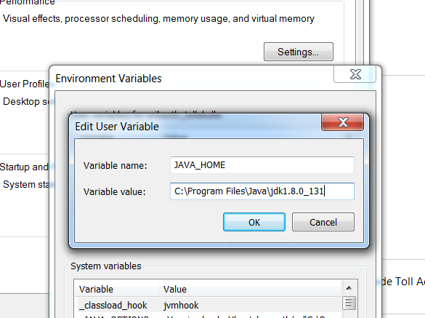

* Add **JAVA_HOME** as a new user variable under User Variable section and provide the location where the java has been installed.

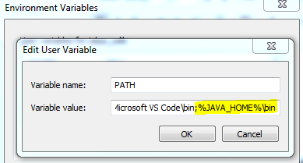

* Append **%JAVA_HOME%\bin** at the end of the PATH variable.

## Eclipse

* Download the Eclipse IDE from below location:

<https://www.eclipse.org/downloads/>

* After downloading run the .exe file with the help of privilege guard and follow the further prompts (which are self-explanatory).

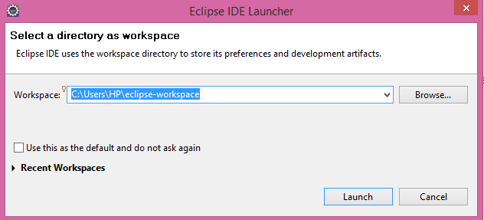

* Once installation completes, go to the installed folder and launch eclipse. Provide the workspace directory or else it will take default workspace directory.

**Path: C:\Users\<user-name>\eclipse\java-2020-06\eclipse**

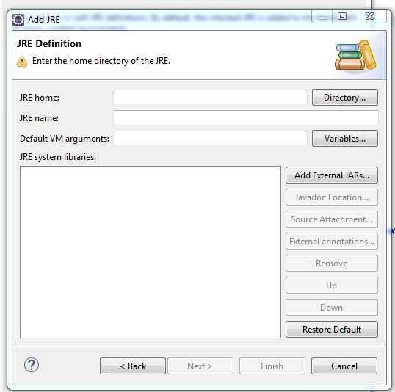

* After launching the eclipse, now we need to provide JDK Path in eclipse. Please follow the following steps

Go to Window🡪 Preferences 🡪 JAVA (Expand JAVA) 🡪 Installed JREs

Now click on Add and select Standard VM and Click on Next.

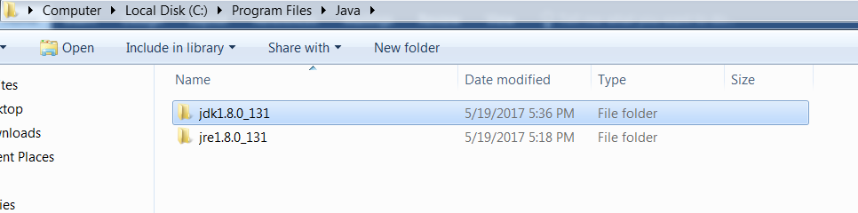

* Click directory and Navigate to JDK installed path and select the folder.

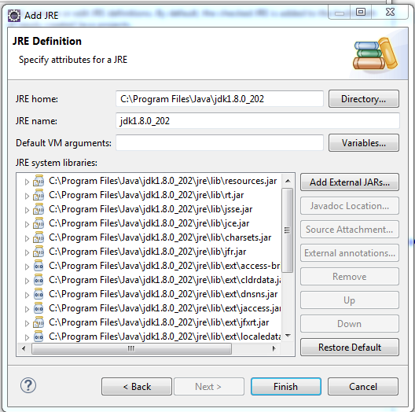

Once the folder is selected, click on Finish button.

### Importing Project In-To the Eclipse

**Git Smart Import**

* Open Eclipse, select workspace, and click launch.
* Go to Files, select Import option.

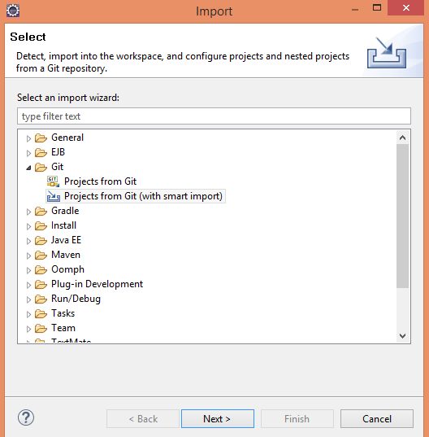

* An import window will get open.
* Click on Git dropdown, select the option Projects from Git (with smart import).
* Click on Next button.

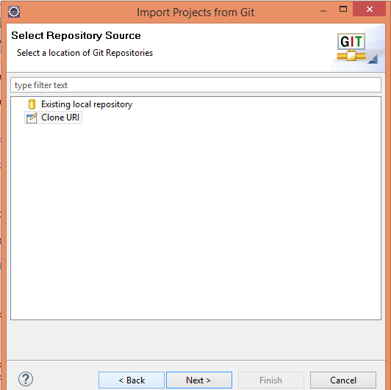

* Import from Git Project window will appear select clone URL option.
* Click on next button.

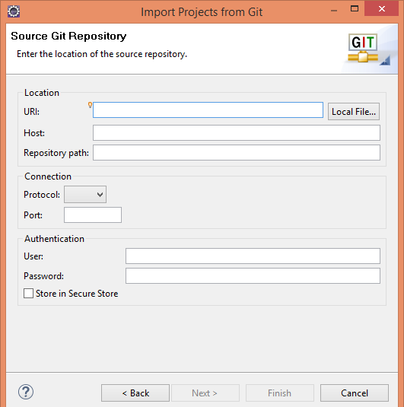

* Provide the Git project URL, and git credentials as username and password.
* Project will start adding into your eclipse workspace provided.

### Importing from Local Repository:

* Open Eclipse, select workspace, and click launch.

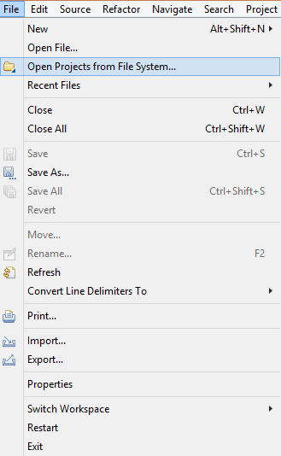

* Go to File and select Open Projects from File System option.

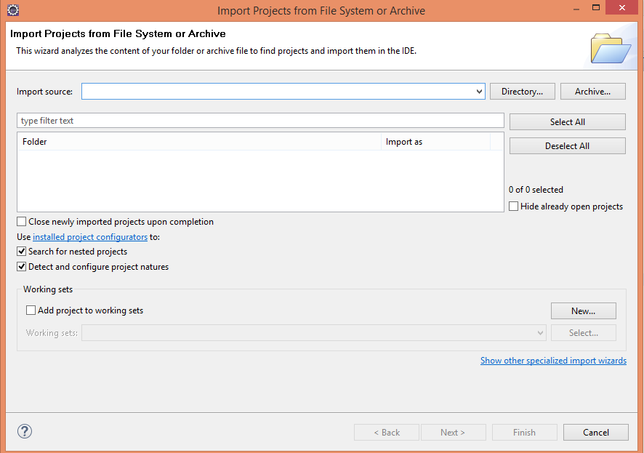

* An Import Projects from File System or Archive window will get open.

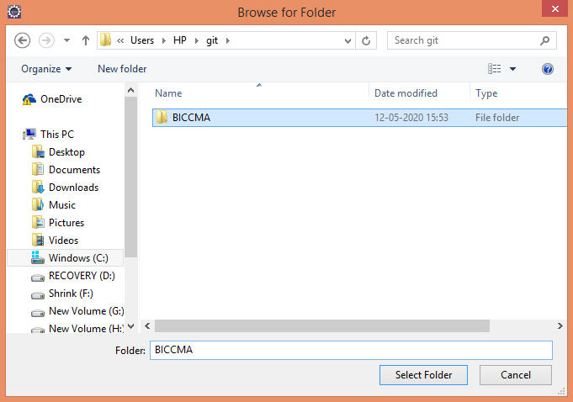

* Click on Directory button and select the directory and folder where your project is present
* Click on Finish button.